Independent Assessment Management Tool
(IAMT)

Quality Plan

 | Reference |  | VIAT-PRD-ENG-PLN-001
 | Version |  | 1.0 draft
 |  | Nom |  | Position | Date & signature
Rédaction |  | A. Bennis |  | System Design Engineer
Vérification |  | P. Vin |  | Head of Audit & Assessment office
 |  | JP. Semengue |  | Lead Assessor
 |  | A. Faghraoui |  | Validation & Test Engineer
 |  | X. Gérard |  | Quality Engineer
Approbation |  | A. Attou |  | Project Leader

VIATTECH Q&S
Entreprise d’Ingénierie et de Conseil en Sûreté de Fonctionnement
Boulevard du Midi 25-27 (Etage 3) (B-1000 Bruxelles)
Phone 02 808 48 46 - Fax 02 410 45 20 - TVA BE 0820.761.936 - E-mail: contact@viattech.com
http://www.viattech.com

Information sur le document

Amendment record
Author | Version | Date | § | Modifications
A. Bennis | 1.0 draft A | 03/02/2016 | all | First version submitted to internal review process.
A. Bennis | 1.0 draft B | 09/02/2016 | all | Adaptations following the internal review by AA.
A. Bennis | 1.0 draft C | 10/02/2016 | all | Adaptations following the internal review by P.V, JP.S
A. Bennis | 1.0 | 18/02/2016 | all | Official release of the documents.

Confidentiality Clause
This document shall not be reproduced, in whole or in part, or disclosed to any Party other than VIATTECH Q&S and the Client, or those officially designated by them to evaluate documents, without the written permission of VIATTECH Q&S.

Table of Contents
1. Information sur le document 2
1.1. Amendment record 2
1.2. Confidentiality Clause 2
2. Table of Contents 3
3. Introduction 5
3.1. Document objective 5
3.2. Domain of application 5
3.3. Abbreviations 5
3.4. External References 5
3.5. Internal References 5
3.6. Known issues 6
4. IAMT Description 7
4.1. European norms and regulation 7
4.2. Independent Assessment Process 7
4.3. Potential users 7
5. Development Process 8
5.1. V Cycle 8
5.2. Concept definition 8
5.3. Software Requirement Specification (SwRS) 9
5.4. Software Architecture Description (SwAD) 9
5.5. Software Detailed Description (SwDD) 9
5.6. Platform coding 10
5.7. Verification activities 10
5.8. Unitary tests 10
5.9. Integration tests 11
5.10. Acceptance tests 11
5.11. User manual 11
5.12. Change management 11
5.13. Baseline management 12
5.14. Tool installation 12
5.15. Training 12
5.16. Maintenance, support and remarks follow-up 12
6. Project Organisation 13
6.1. People in charge and roles 13
6.2. Planning 13
6.3. Progress meetings 13
6.4. Language 14
6.5. Funding 14

List of Figures
Figure 1 – IAMT V development cycle 8
Figure 2 – Planning de développement du projet IAMT 13
List of Tables
Table 1 – Project organisation 13

List of Appendix
None

Introduction

Document objective

This document aims to describe all activities and methods necessary to design, validate and deliver the IAMT release 1.0 with required quality and conform to the input requirements and standards.

Domain of application

This document is applicable to the IAMT release 1.0.

Abbreviations
CR Change Request
CAE Cellule Audit & Evaluation
CSM Common Safety Method
C_ORG Client Organisation
IAMT Independent Assessment Management Tool
IA_ORG Independent Assessment Organisation
LA Lead Assessor
PHP Hypertext Preprocessor
SwDD Software Detailed Description
SwAD Software Architecture Description
SwRS Software Requirement Specification

External References
- Railway applications - The specification and demonstration of Reliability, Availability, Maintainability and Safety (RAMS) CENELEC EN50126 – 1999.
- Norme ISO 9001 version 2000.
- P. Hans-Peter Hoffmann, Systems engineering best practices with the rational solution for systems and software engineering, IBM software group, 2011.
- Systems and software engineering — Architecture description, the latest edition of the original IEEE Std 1471:2000, Recommended Practice for Architectural Description of Software-intensive Systems.
- IEEE 42010:2010

Internal References
- IAMT Concept Specification – Réf. VIAT-PROD-ENG-DNLS-009
- PROC 07 – Audits Externes, Inspection & Evaluation de la Sécurité – Réf. VIAT-QA-PROC-07
- Template – ISA Findings Register (ROBS) – Réf. VIAT-QA-MDL-08
- Template – Plan d'Evaluation – Réf. VIAT-QA-MDL-09
- IAMT Software Requirement Specification – Réf. VIAT-PRD-ENG-SwRS-001
- Manuel Qualité – Réf. VIAT-QA-MNL-001
- PROC 10 – Maîtrise des Documents – Réf. VIAT-QA-PROC-10

Known issues

None.

IAMT Description

European norms and regulation

Many standards ISO, IEC, CENELEC, Yellow Book etc.or regulations such CSM requires an Independent Assessment or Certification process (safety or not) of a given product, (sub-) system, organization, procedure etc. The objective of the independent assessment is to verify if the assessment target meets the requirements of the related standards.

Independent Assessment Process

Independent Assessment is generally performed using two main techniques:
- Safety Audit
The Independent assessment organisation, called IA_ORG, proceeds with interviews of the project development team and verify that organisation, skills, procedures, methods are applied effectively based on associated project plans, company procedures and methods.
- Document assessment or inspection
The IA_ORG will assess or inspect documentation or technical installations, in order to verify if procedures, methods, technics, design etc. are in conformity with standard requirements.

During Independent Assessment, the IA_ORG provides findings and sometimes recommendations in order to comply with applicable standards. Each finding or observation is associated to a severity level.

For each observation, the client organisation, called C_ORG, has to provide detail answers and scheduled action plan to the IA_ORG so that deviations from the standards are eliminated or reduced to an acceptable level.

Only when all or a specific number of severe deviations are addressed properly, the IA_ORG is able to produce a final assessment report and certification.

The assessment activity generally involves the transmission of significant amount of evidence in many type of formats (documentation, photos etc.).

Potential users

The tool is used mostly by IA_ORG and C_ORG during the assessment process. Managers can use the tool for analysing progress indicators and status of any assessment project.

Development Process

V Cycle

The IAMT tool development follows the V cycle process extensively used in the software development industry. The cycle starts with a descending branch by identifying the requirements, then specifies those requirements and implements them in the software design. In the ascending branch, we proceed to the tests, acceptance and maintenance of the tool.

The software engineering workflow is characterized by the iterative incremental cycles through the software analysis and design phase, the implementation phase and the different levels of integration and testing.

The V development cycle applied for IAMT is presented in Figure 1. It is defined according to the method Harmony for system engineering described in ref. [3]. The following paragraphs will detail each phase of the V cycle. Traceability of requirements (vertical and horizontal) is performed based on the requirement repository.

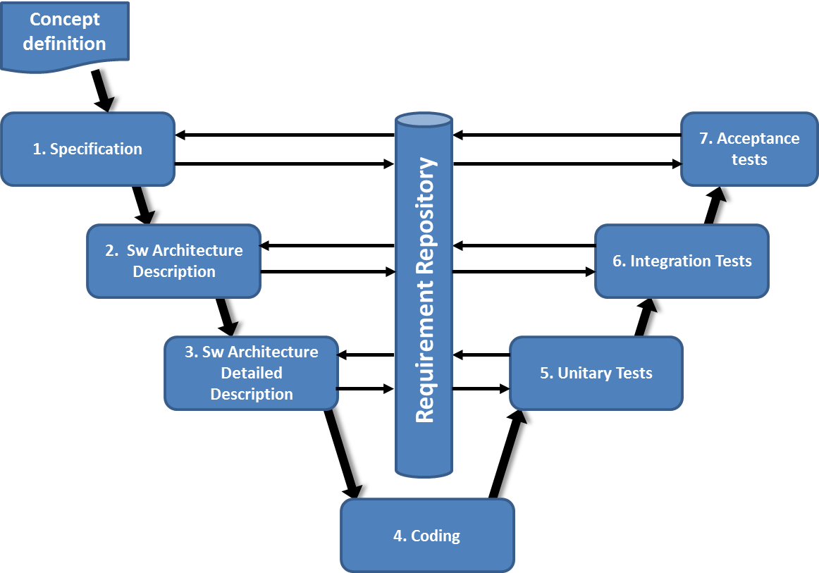
Figure 1 – IAMT V development cycle

Concept definition

Viattech experts using their extensive experience in building and using legacy assessment tools (Excel based) have identified high level and detailed functionalities. These functionalities allow the IAMT tool to assist the IA_ORG and the C_ORG to reach the objectives of the applicable norms and European regulations as well as other targets which are highly relevant when dealing with dependability and safety assurance.

In the document ref. [6], a concept of IAMT is proposed; all the users’ needs and some of the system requirements are formulated.

Software Requirement Specification (SwRS)

The objective of the requirements analysis phase is to analyze the process inputs. Users’ requirements are translated into system requirements that define what the system must do (functional requirements) and how well it must perform (quality of service requirements). User requirements focus on required capabilities. The specification phase consists in transforming the users’ needs into required system functions (“shall” statements) and documented in the SwRS ref. [10]. For traceability purpose, the identified system requirements are linked to the associated users/stakeholders requirements.

The document should put the platform into perspective with other related products (such as the existing hardware infrastructure and Software). It results from this analysis a set of non-functional requirements describing the development constraints, (i.e Interface to other software on the server and performances of the client browser), exploitation constraints (i.e number of simultaneous users to be supported according to the hardware limitation), and performances (i.e storage, processing time, HMI, etc.).

An essential element of the model-driven development process is Model & Requirements Repository. It contains the configuration controlled knowledge of the system under development (requirements documentation, design documentation and test scenarios definitions) and requirements traceability between the different development phases. Therefore the repository is updated at the end of the verification process applied to each phase.

The concept document ref. [6] is considered as input for this phase.

The document delivered at the end of this phase is the Software Requirements Specification (SwRS), including requirement diagram.

Software Architecture Description (SwAD)

The main emphasis of the software architecture description phase is on the transformation of the functional system requirements into a coherent description of system functions (operations). First, we define the system use cases according to the requirements analysis performed in the previous phase. Then for each use case, we define the functions that must be performed by the tool. The functions are then linked and ordered in a sequence and activity diagrams.

The input of this phase is the SwRS ref. [10] defined in the previous phase.

In this phase, we carry out also the creation of requirements related test scenarios all along the top-down design path. These scenarios are also used to assist the bottom-up integration and test phases and, in the case of system changes, regression test cycles.

The output of this phase is the Software Architecture Description. The document content should be compliant with the requirement of the norm ref. [5]. This document aims to provide a high level description of the IAMT architecture. It contains narrative and graphical descriptions of the system functions according to four points of view: Hardware, Logical, Process and Physical view. Each functional requirement is referenced.

Software Detailed Description (SwDD)

This phase consists in decomposing each main function defined in the previous phase into a set of sub-functions in the four views as presented above. The decomposition is done in an iterative way until the resulting sub-functions are simple and easy to realize.

As the SwAD, the SwDD is structured by views. Function and sub-function, where each sub-function is referenced to its main function. Therefore each sub-function is referenced to a requirement.

The input of this phase is the SwAD and SwRS.

The output of this phase is a SwDD that contains detailed description in the four views of each main function, their interfaces, the programing tools and the coding rules. The document includes also necessary specifications to build specific code which can’t be found in the COTS software (SQL, OS etc.) API. This includes specific SQL instructions, HMI design, background code for managing record validation functions etc.

Platform coding

This phase consists in coding the platform. All remaining functions defined in the SwDD that can be fully implemented by the COTS software’s API are defined by the software development engineer having in mind the non-functional requirements such as portability, compatibility, obsolescence etc.

All custom based code is commented so that the link between the SwDD and the code can be traced. Source code is versioned and stored in a specific and non-ambiguous folder on VIBE.

The code is written using software coding best practices as recommended by PHP. The designer also performs unitary tests in an informal way.

The inputs of this phase are the SwDD and SwRS. This last is considered in order to take into account the quality of service requirements during the development.

The output of this phase is an executable application deployed on the server test machine located in VIATTECH’s offices and a documented source code.

Verification activities

The deliverables of all development phases (Concept, SwRS, SwAD, SwDD, etc.) are submitted to internal verification according to the quality document review procedure of Viattech ref. [12]. During this process, remarks/questions and recommendations for correction are formulated by the reviewers.

The proposed architectures and design choices –at each phase of the V cycle- are examined by all the project participants in a design review meeting. A minute of the meeting is made in order to formalize the modifications and remarks to take into account, and update the model/requirement repository if necessary.

Requirement traceability is verified in each phase. For this aim, the deliverable of each phase should contain a table which establishes the requirement satisfaction by the functions or sub-functions.

The input of this activity is the document provided at the end of the current phase.

The output of this activity is the Verification Report that contains remarks and modification requests in order to comply with predefined system requirement.

Unitary tests

Unitary tests are performed at the end of each sub-functions coding. The main aim of this phase is to identify eventual bugs located at each coded sub-function.

Unitary tests are specified and performed formally by the Validation & Test Engineer. Each sub-function test case consists in evaluating the sub-function output for a predefined input. Those tests will be defined based on the SwDD, also they will be performed manually.

The input of this phase is the SwDD.

The output of this phase is a Validation Report of the realized unitary tests including the tests scenarios and results.

Integration tests

Based on the SwRS and SwAD specifications, specific functional and non-functional tests are specified. These tests aim to eliminate any errors, faults or inconsistencies with regards to SwRS and SwAD requirements.

The tests will be performed according to the tests scenarios defined in the SwAD. The tests case will be defined according to the requirement type: functional, performance, and constraints. Therefore, we will have to consider three type of verification: Sequence tests, verification by demonstration, and verification by analysis.

The input of this phase is the SwRS and SwAD.

The output of this phase is a Validation Report of the realized integration tests including the target baseline, the tests scenarios and results, the eventual issues and recommendations for correction if applicable.

Acceptance tests

A subset of the functional tests and scenarios selected by the users can be performed at VIATTECH offices. If the tests are passed successfully, the product can be put into production on a pilot assessment project.

User manual

In order to provide assistance to the potential stakeholders (users, system administrator and CAE team), a user manual will be produced by the platform designer. The manual shall provide:
- A preface, containing details of related documents and information on how to navigate the user guide.
- A contents page
- A guide on how to use at least the main functions of the tool
- FAQ (Frequently Asked Questions)

Change management

Any anomaly reported during the development, testing, usage and after hand-over is recorded on BUGNET tool. This data base contains the baseline to which the error is originated, the description of the anomaly, the baseline to be corrected, the solution and the status of the anomaly.

When the anomaly is detected by the user, the cause is analyzed and a solution is proposed.

Any functional enhancement or additional function not included in the approved SwRS is also recorded as above. However the implementation depends on the amount of the change, the priority and the complexity of the change.

Baseline management

All deliverables produced in this project is referenced and versioned. During the project, it is ensured that all documents are consistent between them. The consistency between deliverables is ensured by the conclusion of the verification activities (traceability of requirements). A customised Excel sheet (Baseline Register) is used to track deliverables and their respective baseline. The deliverables are:
- Requirement specification and design documents, user manual etc.
- Source code
- Software binaries, configuration files and COTS

The deliverables should update the model/requirement repository.

Tool installation

The IAMT tool will be implemented on the VIATTECH’s servers. The application is web based therefore no installation is needed in the C_ORG.

Training

Sessions of training are given to specific users designated by the manager. The purpose of these sessions is to present the main functionalities of the tool and examples of its application in the railway safety management process.

Maintenance, support and remarks follow-up

A technical support is provided to the tool users. Requests for improvement and any remark raised during a prolonged period after delivery of release 1.0 are collected via change request in BUGNET and processed for the elaboration of the next baseline of IAMT.

Moreover, the needs for improvement will be identified by using the tool on a “pilot” assessment project.

Project Organisation

People in charge and roles

The team in charge of this project involves the following profile:
Role | Main responsibility | Name
Head of Audit & Assessment office (CAE) | In charge of production of the tool user requirements, technical concept and acceptance step. | P. Vin
Lead Assessor (CAE) | Potential user of the tool in charge of reviewing the specifications and testing during the acceptance step. | JP. Semengue
System Design Engineer | In charge of the software requirement specification SwRS, elaborating the SwAD, SwDD and coding the tool. | Bennis
Validation & Test Engineer | In charge of the verification tasks and validation tests activities (tests scenarios and execution). | Faghraoui
Quality Engineer | In charge of the quality assurance follow-up during the software development project. | X. Gérard
Project Leader | In charge of coordination of the engineering activities, respect of planning, cost and product quality. | Attou

Table 1 – Project organisation

Planning

The planning of tool delivery is presented in Figure 2. It is reviewed with the Project Leader on a regular basis. The project is started on the first February (T0). The release 1.0 beta of IAMT tool submitted for tests is available end of 01/2017. Acceptance of the validated version of the tool is expected end of 07/2017.

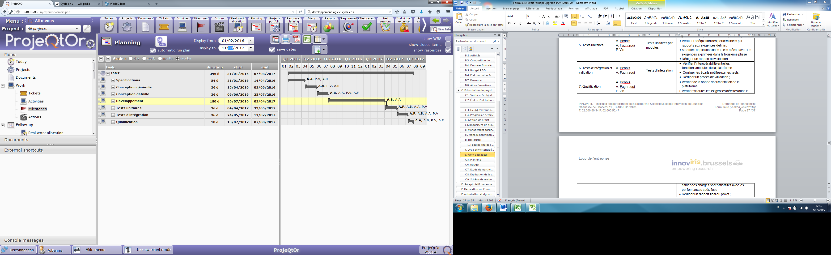
Figure 2 – Planning de développement du projet IAMT

Progress meetings

Design Reviews are put in place on a regular basis (at least 1 every month) with the Head of Assessment office (CAE) and the Project Leader in order to review the progress of activities and to discuss specific issues.

Language

The documents delivered by Viattech in the frame of the release 1.0 development are in English.

Funding

A R/D funding request will be submitted to Brussels region (INNOVIRIS organism) in order to get partial subsidies for the project development. The amount of subsidies provided by Brussels regions covers a part of the overall project cost.

